Loan taken on: 29/10/2014

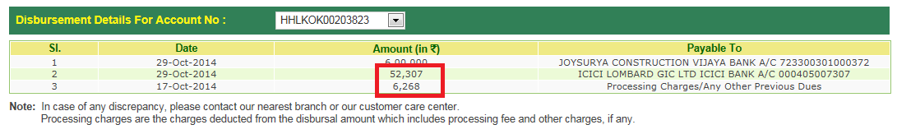

**Amount deducted from account (HDFC):**



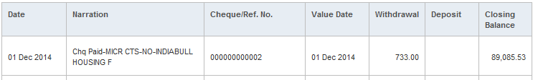

**Total EMI: (72-4) =68**

**Total EMI: (68 + 4) =72** (After Top up)

**EMI: 01**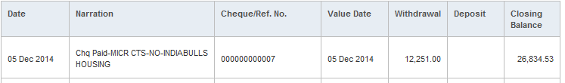

**EMI: 02**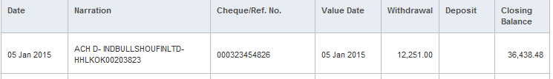

**EMI: 03**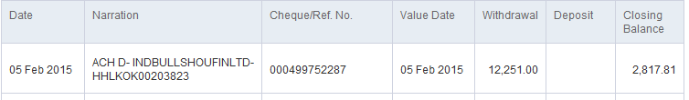

**EMI: 04**

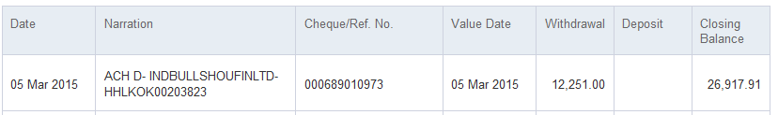

**EMI: 05**

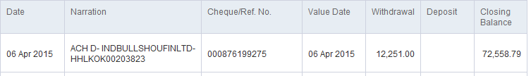

**EMI: 06**

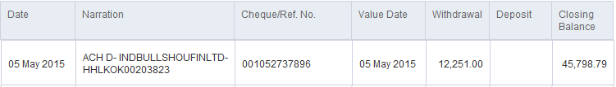

**EMI: 07**

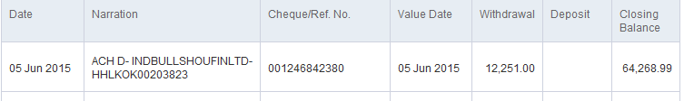

**EMI: 08**

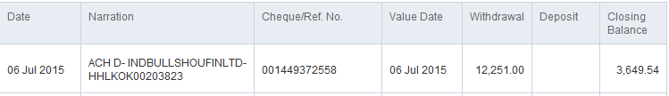

**EMI: 09**

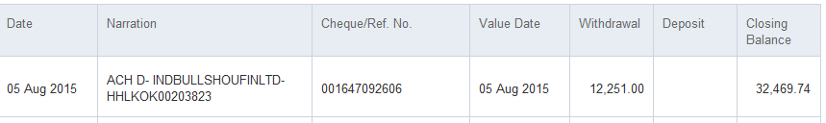

**EMI: 10**

**Top up done on: 31/08/2015**

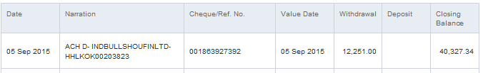

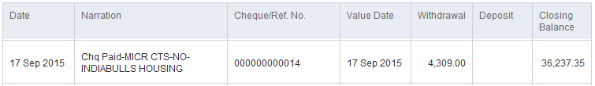

**EMI: 11**

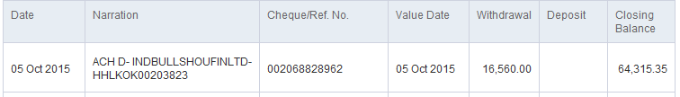

**EMI: 12**

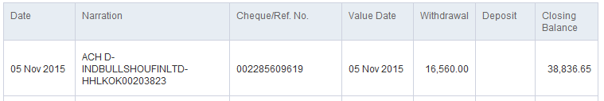

**EMI: 13**

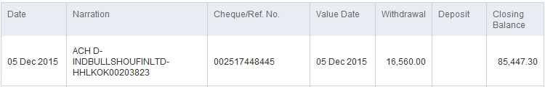

**EMI: 14**

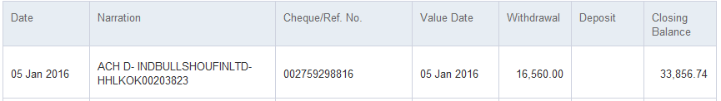

**EMI: 15**

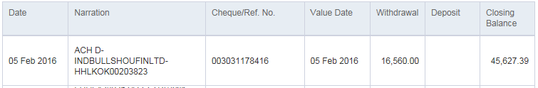

**EMI: 16**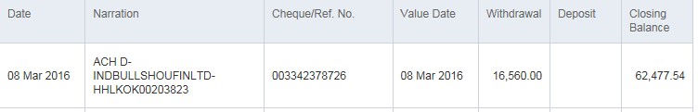

**EMI: 17**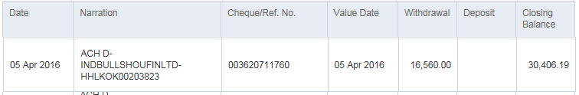

**EMI: 18**

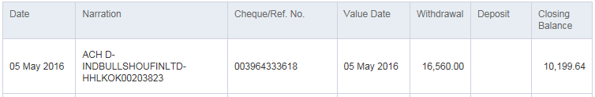

**EMI: 19**

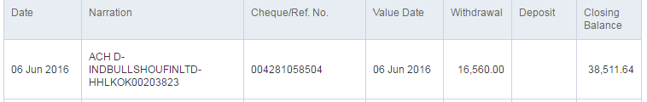

**EMI: 20**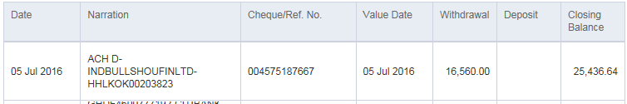

**EMI: 21**

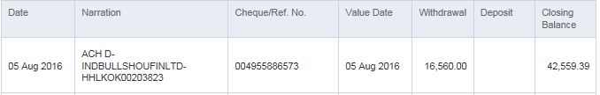

**EMI: 22**

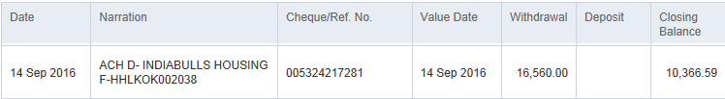

**EMI: 23**

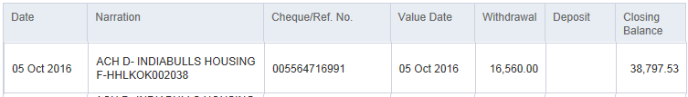

**EMI: 24**

Check given on 15.12.2016 for EMI on 5th November 2016

**EMI: 25**

Check given on 20.01.2017 for EMI on 5th December 2016

**EMI: 26**

Check given on 14.02.2017 for EMI on 5th January 2017

**EMI: 27**

Check given on 10.03.2017 for EMI on 5th February 2017

**EMI: 28**

Check given on 17.04.2017 for EMI on 5th March 2017

**EMI: 29**

Check given on 11.05.2017 for EMI on 5th April 2017

033-39974709 -->Ashoke India Bulls

033-39974703

033-39974723🡪

18002007777🡪 Toll Free

9088201721🡪sumanta sarkar

Home Loan a/c number: HHLKOK00203823

<https://loans.indiabulls.com>

vijaysah

Ramapatidevi1

1. My Home Loan a/c number is: HHLKOK00203823. Due to unavailability of CTS cheque at the time of applying for the loan I had given a DD of rs 1124 drawn in favour of India Bulls Housing Finance Limited. But this amount has not been adjusted as the processing fees in the loan sanction letter.

Earlier an amount of rs 5618 was told to us as the processing fees for the loan of rs 9 lacs. Consider an extra amount of rs 650 as the admin fees, total processing fees should be rs (5618+650)=6268. But since we had already paid an amount of rs 1124 in the beginning while applying for the loan now the amount which should be deducted from loan account should be rs (6268-1124)=5144. But a total amount of rs 6268 has been deducted from my home loan account for the loan processing fee.

So either return the DD to us or adjust the processing fees by refunding rs 1124 in the home loan account.

Please consider this as urgent and resolve the issues.

1. My Home Loan a/c number is: HHLKOK00203823. A sum of RS. 52307 was wrongly deducted for the property insurance from ICICI Lombard for me and my nominee both. But we did deceive the insurance paper for one person (only for the account holder i.e me). So a refund of the remaining amount of approx. RS 24307(=52307-28000) has been initiated from ICICI Lombard the refund ID being **1040228699.** But still the amount has not been credited into my account. Please look into this and refund the amount into my Home Loan account at the earliest.
2. **Rs.28066 refunded to India Bulls from ICICI Lombard as told by customer care executive** over phone
3. India Bulls Request ID (Received over phone): **007074084**
4. My Home Loan a/c number is: HHLKOK00203823. A sum of RS. 52307 was wrongly deducted for the property insurance from ICICI Lombard for me and my nominee both. But we did deceive the insurance paper for one person (only for the account holder i.e me). So a refund of the remaining amount of approx. RS 28066 has been initiated from ICICI Lombard the refund ID being **1040228699.** I also had a talk with India Bulls customer care executive. He told that an amount of RS 28066 has been refunded to India Bulls but it is not yet reflecting into the Home loan account. But still the amount has not been credited into my account. Please look into this and refund the amount into my Home Loan account at the earliest.

Hi Soumen,

My Home Loan a/c number is: HHLKOK00203823. My concern is that the rate of interest has reduced 3 times since the loan started but the EMI amount has NOT reduced, it’s same. This is shown in below screenshots. Could you please look into the matter and revert back ?

